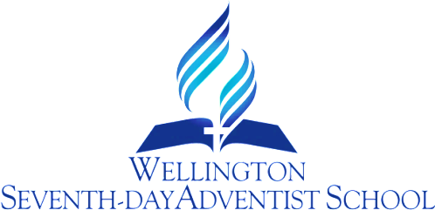

TIKANGA & TE REO
PROCEDURE
RATIONALE:

Māori studies, i.e. the language, customs, cultural values and the history are the heritage of all New Zealand children. Without this basic facility and understanding, our students could find themselves socially inadequate in some future situation.
PURPOSE:
To value and reflect New Zealand’s bi-cultural heritage.
GUIDELINES:

- What the school does must be the logical result of genuine concern and understanding and become a comfortable dimension of the school and its wider community.
- Students and their parents need to be made aware of :
- The Māori history of this area.
- The importance of correct pronunciation of Māori as a courtesy and skill.
- The necessity of understanding customs and cultural values to be comfortable and acceptable at a Hui, powhiri, tangi, and many other social occasions.
- The importance to intellectual growth of embracing more than one language and how this stimulates all language work.
- The necessity, because of the increased mobility of our workforce, of preparing our children to be able to socialise with confidence based on understanding, in any part of New Zealand.

CONCLUSION:

That we help to develop NZ citizens who will be comfortable, confident and happy with their dual heritage.

Review Responsibility: DP & Teaching Staff

Date Confirmed: …………………………………………………

Principal: ……………………………………………………………..

