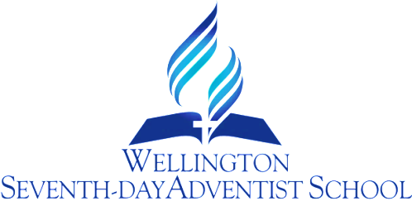

MAORI ACHIEVEMENT
PROCEDURE

PURPOSE:
- To involve Maori community/parents in identifying the needs of their students.
- To monitor and improve the achievement of Maori students.

OBJECTIVES:

- The school takes responsibility for initiating and maintaining a process of consultation with members of the school’s Maori community/parents of Maori children to help identify important learning needs of our Maori students.
- The purpose and intended outcome of the consultation are effectively communicated by the school through provision of clear background information.
- Consultation arrangements make appropriate decisions on place, pace and protocols. Consultation is face to face.
- During the consultation process, Maori are asked to come up with issues and suggestions concerning the achievement of Maori students.
- The school keeps a written record of consultations. The record includes summary information on dates/places of meetings, turnout, and issues/suggestions raised by Maori.
- As a consequence of consultations, targets for improving the achievement of Maori students are recorded and plans developed for reaching those targets.
- The school reports through the Board and reviews the achievement of its Maori students.
- Should the Maori community/parents not respond to consultative opportunities, the Board, Principal and staff develop targets and request feedback from Maori parents.

GUIDELINES:
- What is the school already doing for Maori achievement that can be built on to focus on further acceleration of learning?
- What could be done differently so more Maori students could benefit?
- What culture changes need to be made – eg developing new inquiry initiatives for students and whanau, self-motivation instead of relying on teachers to drive learning?
- What relationship building is needed eg partnerships in learning with parents, whanau and iwi?
- How can capability be built to support the focus on effective learning for Maori students?
- What are we doing to accelerate progress so that a shift upwards in achievement is being made?

Review Responsibility: Principal, DP & BOT PIC Maori

Date Confirmed: ……………………………………………….

Principal: …………………………………………………………..

MAORI CONSULTATION

Date: …………… Meeting with: …………………………………
- Are we meeting the needs of your child/ children at school?
- Are there things we could do better?
- How do you want your child’s achievement reported?
- Any comments and/or suggestions:

Parent(s)/caregiver(s) signature: ……………………………….

Teacher’s signature: ....................................................

MAORI CONSULTATION

Date: ………………………… Meeting (hui) with:……………………………………………

HOW CAN WE IMPROVE ON WHAT WE ARE DOING?
- What aspects of Te Reo (Maori language) and Tikanga (Maori culture) do you and/or your child value?

- What would you and/or your child like to learn more about in Te Reo and Tikanga at our school?
- How can you provide support or help to further develop Te Reo and Tikanga learning at our school?

Parent/Caregiver signature: ………………………………………….

Teacher’s signature: ……………………………………………….

