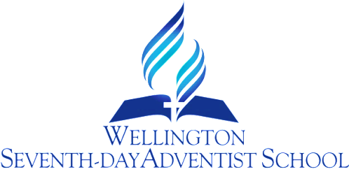

COPYRIGHT COMPLIANCE
PROCEDURE

RATIONALE
- God requires us to obey the laws ordained by civil authorities. This school is governed by law with respect to the use of musical scores, videos, books, films and other copyright materials. Compliance is essential.
- The school will comply with the Copyright Act and any subsequent ammendments.
The school is licensed annually by Copyright Licensing Ltd for the following coverage.

GUIDELINES

1. Copying of Copyright Material under the Licence shall be limited to the following:
1.1 Copying of the whole or any part of an article from a periodical publication or more than one article from the same periodical publication only if the articles relate to the same subject matter;
1.2 Copying of up to 10% of a work (other than an article in a periodical publication) or one chapter of the work whichever is the greater;
1.3 Copying of up to 15 pages of the whole or part of a single work contained in a collection of works notwithstanding that such works may be separately published;
1.4 Copying of the whole of an artistic work (such as an illustration) where it is published in conjunction with a textual work and is produced as part of a copy from that work;
1.5 Copying of up to and including the whole of an out of print work providing that a person on behalf of the licensee has made enquiries of CLL and CLL replies in writing that CLL is satisfied that sufficient copies of that work cannot be obtained within a reasonable time at an ordinary commercial price;
1.6 Making a repeat copy from a work within 14 days provided that such copy is not made by the same staff member for the same class;
1.7 Copying of reproductions of copyright material obtained through the Interloan service between prescribed libraries in New Zealand provided that such copyright material cannot be purchased or obtained from any other source and that such copying is limited to the extent outlined in 1.1 to 1.6 above.

2. The number of copies made of any one item of Copyright Material at any one time shall not exceed:
2.1 The number needed to ensure that each Authorised Person and Enrolled Student intended to receive a copy (in one or more academic years) receives only one copy; plus
2.2 The number needed to replace copies made previously which have been lost where the loser has satisfied an authorised person of the loss; plus
2.3 Not more than a further 10% as spare copies.
3. Compilations
Copyright material may be included in inhouse compilations or workbooks supplying course material provided each extract does not exceed the foregoing limits and the source of each extract is appropriately identified.

Excluded Works
“Excluded Works” are works within the following categories:

● Works downloaded from the Internet;
● Printed music (including the words);
● Loose maps and charts;
● Unpublished religious orders of service (notwithstanding that these may be available to authorised persons);
● New Zealand newspapers ;
● House journals and other free publications primarily for employees of commercial businesses, industrial undertakings or public services;
● Separate illustrations and/or photographs that are not published in conjunction with any other work so as to come within the provisions of clause 1.4 above;
● Any work on which the Owner has expressed and prominently stipulated that it may not be copied under a copyright reprography Licence of this nature;
● Privately owned documents issued for tuition purposes and limited to clientele who pay fees;
● Theses, dissertations and student papers (notwithstanding that these may be available to authorised persons).

CONCLUSION

By ensuring that the Copyright Act provisions are adhered to and the school has a Copyright Licence it will be deemed that all staff will diligently carry out copying within the bounds of the schedules listed.
By complying with the laws of Copyright the school respects the law of God, the law of the
land, and the rights of the owner.

Review Responsibility: Principal & Office Manager

Date Confirmed: 3 July 2017

Principal: ……………………………………………………………..

