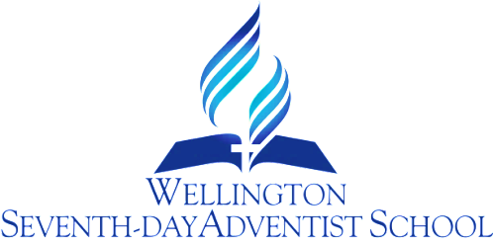

NUTRITION
PROCEDURE

RATIONALE:
Teachers and parents recognise that nutritious food is essential for children’s health, growth and learning. It is important to reinforce what we teach, by providing an environment that supports healthy eating through the lunch orders and role modelling by staff and whanau.

AIM:
To incorporate healthy eating through a whole school approach, as outlined below.

GUIDELINES:
Staff will work towards ensuring that:
1. Healthy eating is included in the curriculum each year in all syndicates.
2. School menu items are healthy, according to the NZ Food and Nutrition Guidelines.
3. The majority of food coming into the school for sale fits into the NZ Food and Nutrition Guidelines for maximum health.
4. Food available during school events is a healthy choice.
5. Children are encouraged to wash their hands before morning tea and lunch.
6. Teachers supervise children to ensure as much of their lunch is eaten as possible.
7. Children are encouraged to bring water bottles to school and drink water regularly.
8. The school actively discourages the consumption of lollies and junk food at school.
9. The school actively encourages vegetarian food be brought for shared lunches and school events, as per Seventh-day Adventist health guidelines.
10. Vegetarian food only will be available for sale during fund-raising events.

Review Responsibility: BOT H/S person, Staff H/S Co-ordinator, DP & Principal

Date Confirmed: 14 February 2017

Principal: ..................................................

