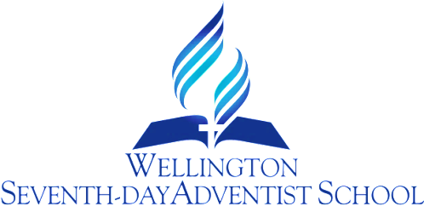

WATER ONLY PROCEDURE

OUR SCHOOL IS WATER-ONLY

Rationale
We care about the health of our students.
Sugary drinks¹ are one of the most significant causes of poor oral health and contribute greatly to childhood obesity and Type 2 diabetes.

We care about their achievement
Sugary drink consumption is associated with problem behaviours. Studies have found poor diet and nutrition are associated with lower academic achievement.

Our commitment
We will ensure parents and students receive clear, consistent messages about the importance of healthy choices and the impact of sugary drinks by:

- continuing to educate students about the importance of healthy drink choices and the benefits of consuming water
- actively promoting water as the best option in school publications
- ensuring staff commitment to model healthy drinking habits.

And we will create an enabling environment by:
- actively discouraging sugary drinks being brought to school by students
- providing water as the only drink option for students
- allowing students access to water during class time
- not associating our school with programmes that promote sugary drinks
- ensuring school lunch options don’t include sugary drinks
- ensuring sports teams will only use water as their source of hydration
- not selling sugary drinks as part of fundraising, school galas, or other celebrations.

¹ Any beverage that contains added caloric sweetener usually sugar. The main categories of sugary drinks include soft-drinks/fizzy-drinks, sachet mixes, fruit drinks, cordials, flavoured milks, flavoured waters, cold teas/coffees, and energy/sports drinks.

Review Responsibility: Principal, BoT
Date Confirmed: 31 October 2017

Principal: .................................................

